**Learning Outcomes**

1. Adding Tab Layout
2. Understanding Intents
3. Webview and Options Menu

**Tab Layout**

A TabLayout is for displaying more than one view in a single view. The TabLayout works on selected tab. if the tab is selected, the respective view for it would be displayed.

**TabActivity**

A TabLayout could be achieved by using the TabActivity. In this example we would see four tabs such as Home, Events, People and Comments.

For each Tab, we need to have a Layout, an Activity.

If we want to add 4 tabs we need to add 4 layout files and 4 activities.

So let’s get started.

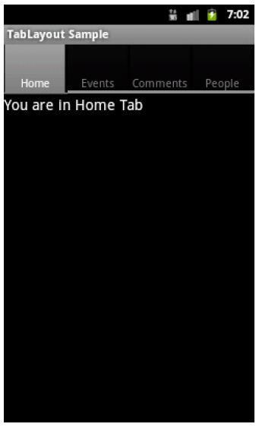

**Add four layout files**



The above Layout folder consists of all the above mentioned Layouts. For demo purpose each Layout has a TextView encapsulated inside a LinearLayout.

**Add four Activities**









**In the MainActivity.cs**



**Intents**

Design a layout as shown in the diagram

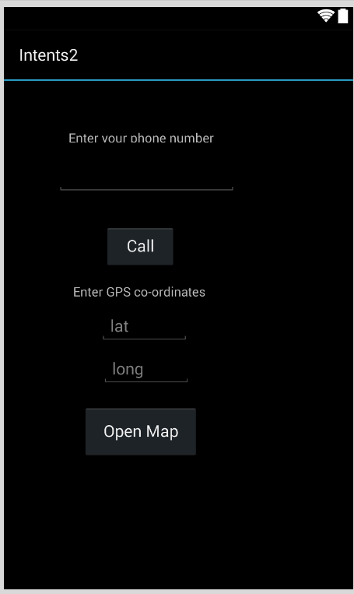

**Starting a Phone Dialer and a Map**

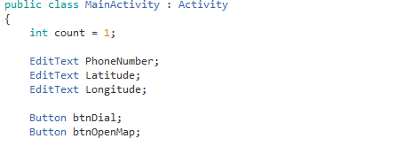

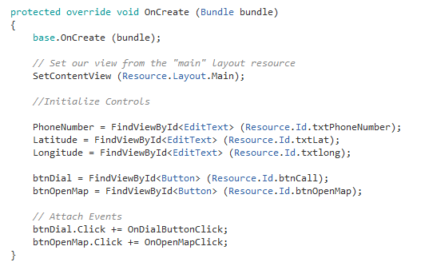

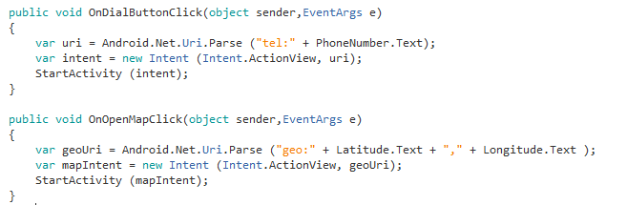

**Options Menu Demo**

Design a layout as shown below.

**Insert a full screen WebView.**

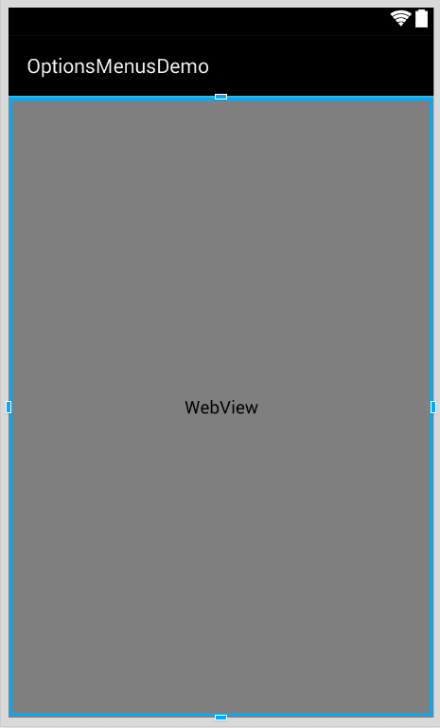

**MainActivity.cs**

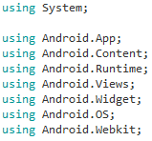

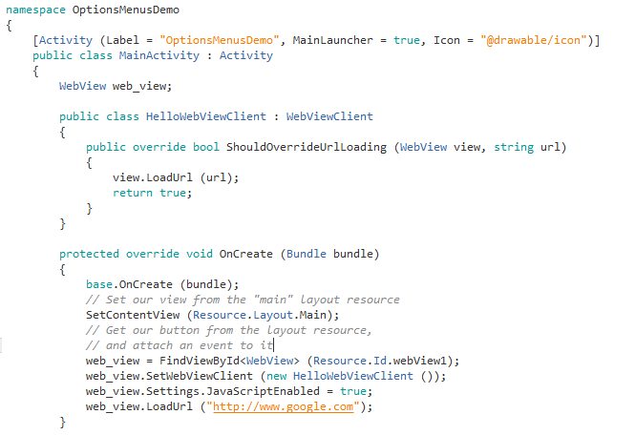

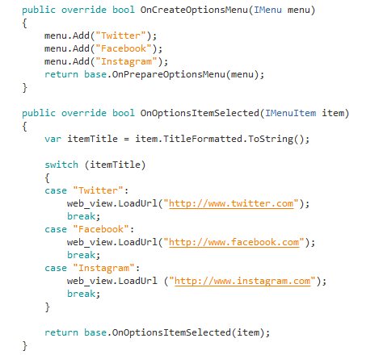

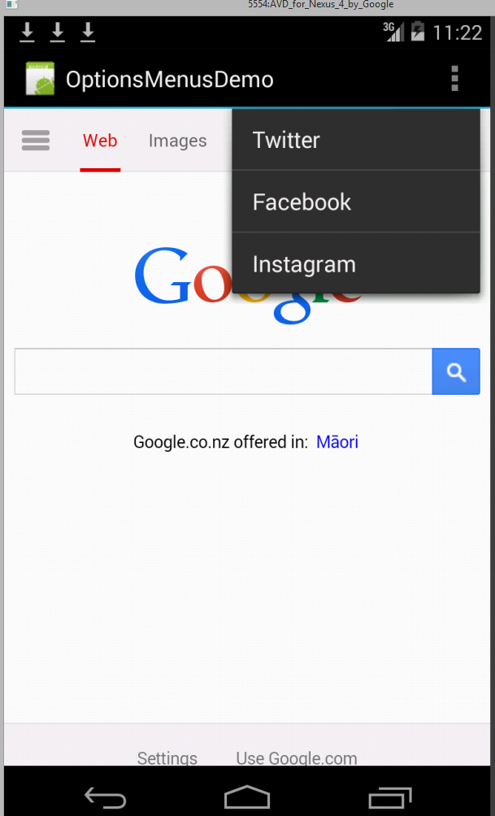

**Exercise**

Implement the Rock Scissors Paper game

